***This documentation is to show future developers how to setup Event Tracking System and work with it locally.***

Things to setup:

* MySQL database on local machine
* IDE / Text Editor
* Chrome Extension
* GitHub Repo

Google Chrome Extension:

In chrome there is an Extension called:

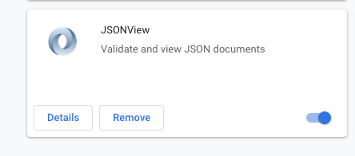

This helps with viewing the JSON file when working with the back-end.

BEFORE - EXTENSION:

AFTER - EXTENSION:

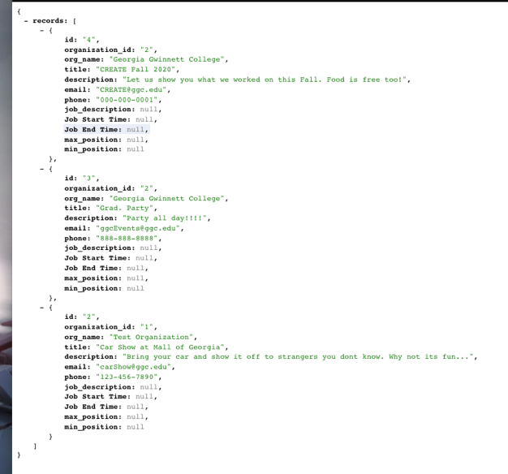

For PC/MAC users:

1: Download and install any text editor of your choice.

|  |  |
| --- | --- |
| ***IDE*** | ***Editors*** |
| PHPStorm | VS Code |
| Netbeans | Atom.io |
| Visual Studio | Sublime Text |
| ETC.. | |

2. Next you need install PHP , MySQL , PHPMyAdmin and Apache

Best way to do this is to install

AMPPS - <https://www.ampps.com/downloads>

3. Pull the GitHub repo to a folder in your local machine and make a copy of it somewhere else

4. Then you need to pass the folder to AMPPS.

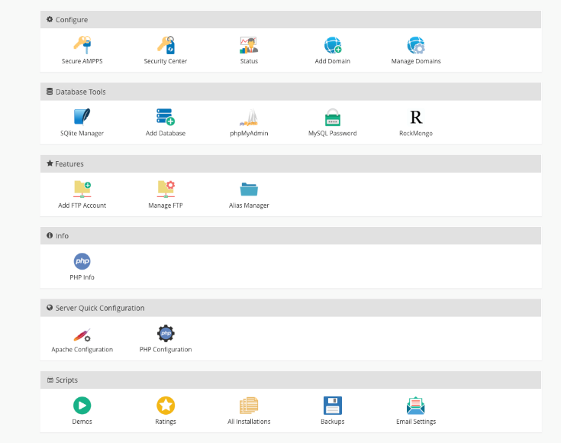

AMPPS (Domain Path) should be directed to your repo(copy) folder under the add Domain tab

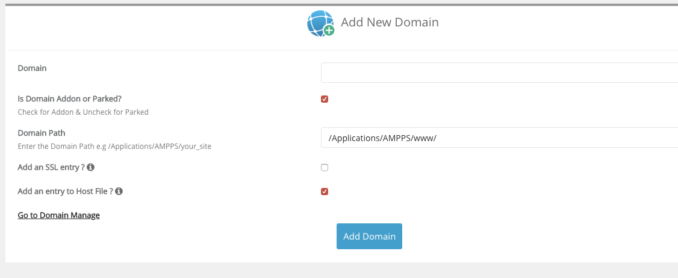

These might also help

<http://www.ampps.com/wiki/Adding_a_Domain>

<https://www.youtube.com/watch?v=iqA5-0JIa4o>

<https://www.youtube.com/watch?v=siWWeaEy5vM>

5. Upload database for project to PHPMyAdmin.

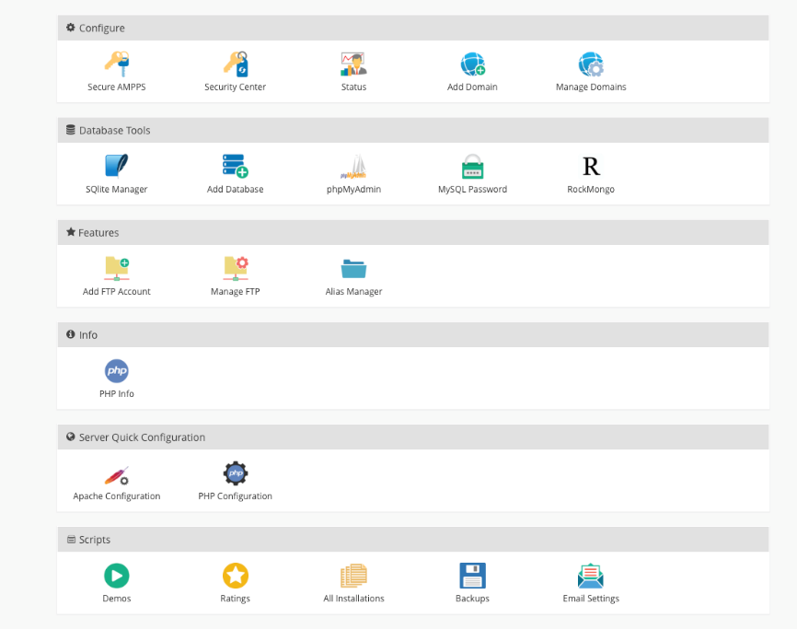

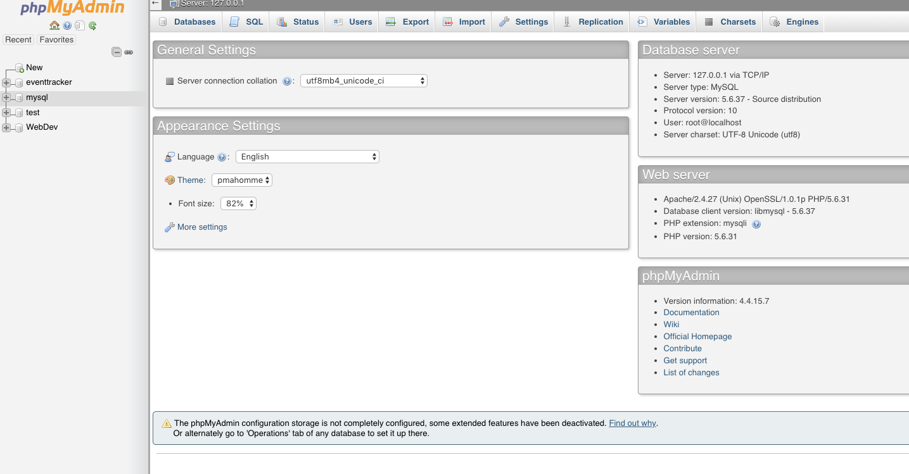

* Create a name for the database (YELLOW BOX)
* Then Click that database... and go to Import (RED BOX)

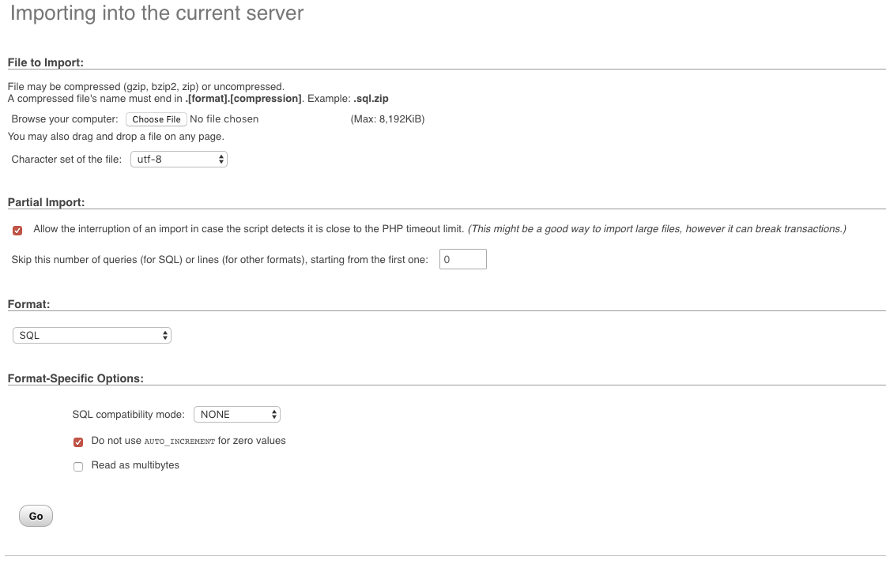

* Then find the file .sql in your repo folder

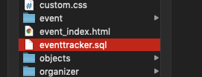

6. Next find your Domain Folder to change a few things to work with your local database

- in your folder find the config folder and open database.php with an Editor

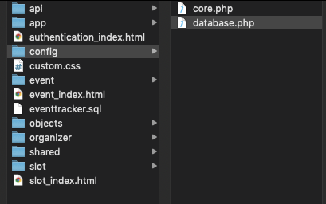

* Then edit the code in the (RED BOX) below to match your local database info.
* You can find this info in the phpMyAdmin.

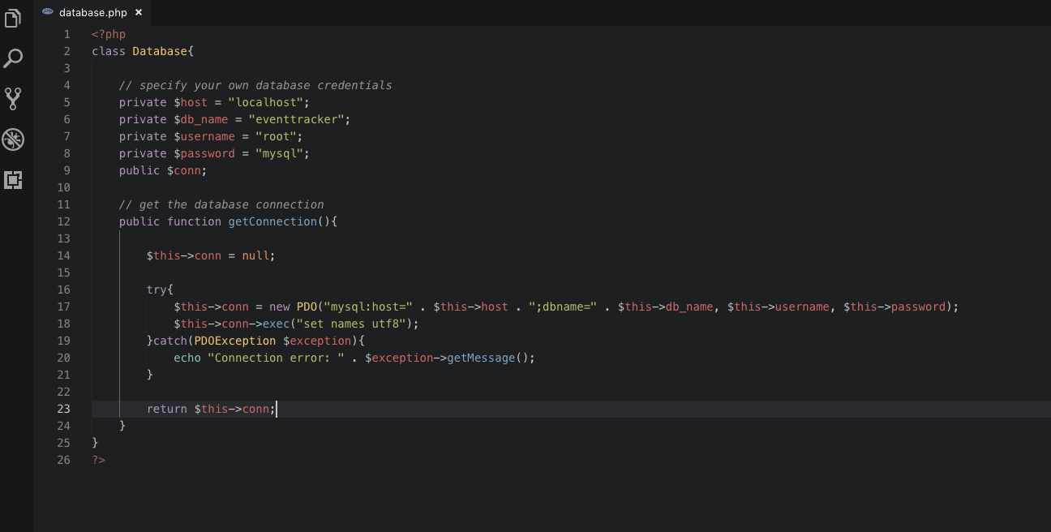

7. If everything is completed correctly then you can start working with the database and code.

